Doc. Number: | 15698 | Approvals
Revision: | 1 |  | Signature | Date
FileName: | 15698R1.doc | Engineering:
Title: | Switching Taurus Media
Originator: | M. Turcot
Date: | Jan. 27 2005
Revision History
Rev. | Date | Author | Description
1 | Jan. 27 2005 | M. Turcot | Initial Revision

Switching Taurus Media

Note: This document is to be used when you receive a Taurus which has been configured for a media device you have not purchased. It is designed with the intention of being easy guidelines for new customers to configure the storage media quickly and efficiently. This procedure is written for customers who desire to change from IDE Hard Drive to Compact Flash (CF).

This procedure is completed using the integrated UI but the same can be completed using the external browser. Simply connect the Ethernet cable to your network or laptop and log on to the Taurus (See section 3.1.4 of the Taurus User Guide). The IP address of the unit is indicated on the Current Status Page.

- Unpack the Taurus, cables and associated media.
- Open the Taurus media door and insert the desired media (Compact Flash or IDE).
- Close the media door.
- Connect all the required cables (Power, Ethernet, etc…).
- Power up the Taurus and initialize the integrated UI (See section 3.1.2 of the Taurus User Guide).
- You should see the following page come up: 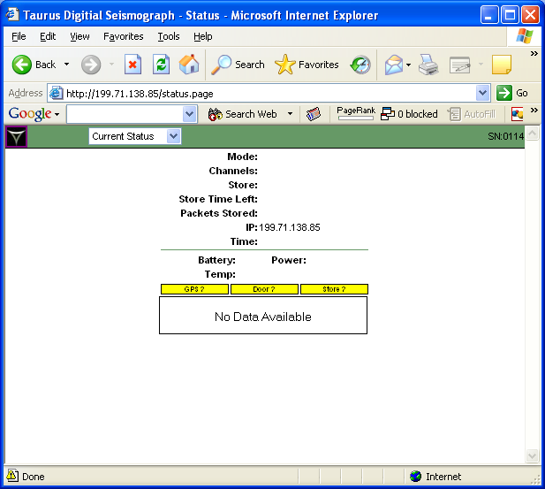

- Select Factory Settings from the drop down menu. 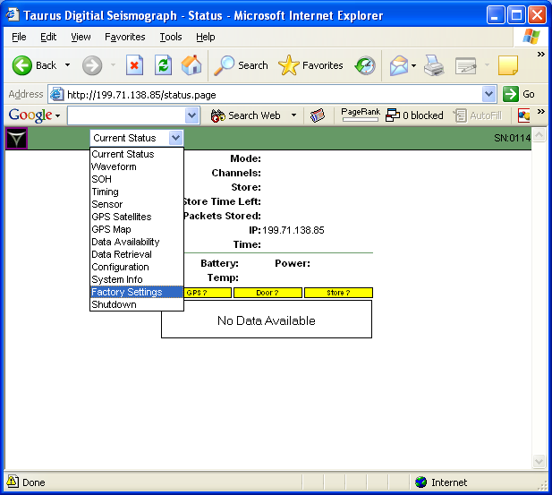

- From the Factory settings menu select the Storage hyperlink. 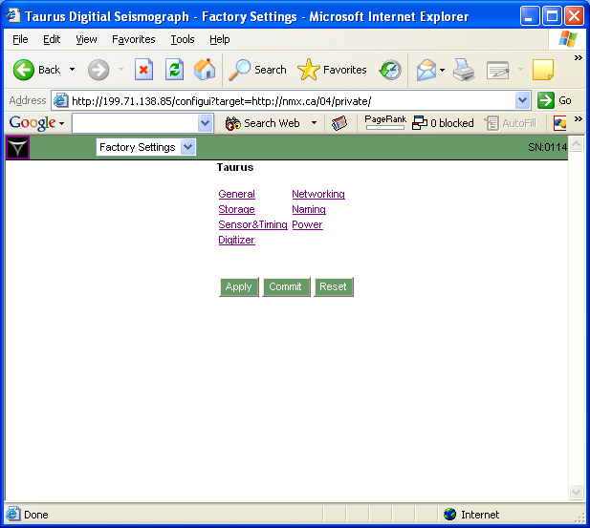

- From the Storage main menu, select the Compact Flash from the Media drop down menu. 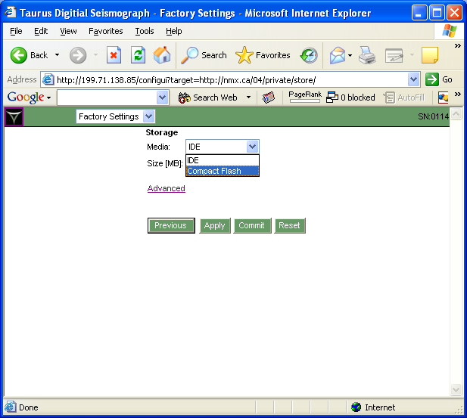

- You may have to adjust the size of the storage device in order for the changes to take affect.

For example:
Media Type Actual Size Configured Size

CF 1 GB 800 MB
CF 4 GB 3800 MB
IDE 40 GB Full
IDE 40 GB 30 000 MB

- Apply the changes.
- Once the message “Changes Applied” appears, Commit the changes.
- Once the new settings have been committed go to the Configuration menu using the main drop down menu. 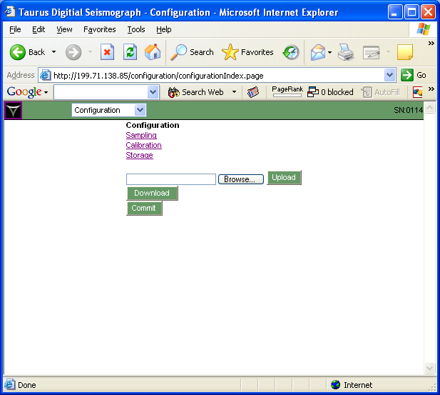
- Once within the Configuration sub-menu select the Storage hyperlink. 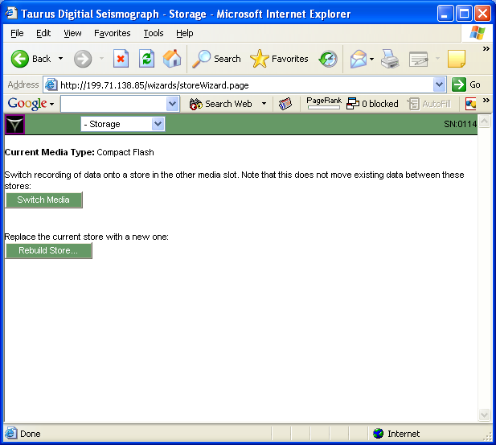

- Click on the Rebuild Store… button.

Note: This action will destroy all data in the current Store, and that this action is not reversible.

- Select the Rebuild Store… button again.
- Select OK if you want to proceed.

- Once the Taurus indicates that the store is done select the shutdown page from the main Taurus drop down menu and select the restart button. 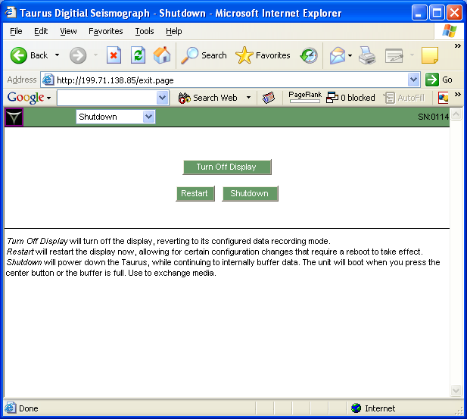

- You will need to re-initialize the integrated UI to confirm that the Taurus is recording data.

