Neil asked me to send you software to read Taurus data from Compact Flash onto your computer. Here's the procedure. If you have any questions or problems please contact me at support@nanometrics.ca or 1-613-592-6776 x266.

The Nanometrics program TaurusExtract is quite large at 2.7 MBytes, so I will send it in a separate eMail.

1. Go to the following site and download the exploer2fs application. This allows you to read ext3 files from the CF and save them onto your computer's drive.
http://uranus.it.swin.edu.au/~jn/linux/explore2fs.htm

2. Install and start the explore2fs.exe program.

3. I asssume you have a Compact Flash reader plugged into your computer.

4. Remove the CF from the Taurus following the published procedures. Since Taurus should not run without memory media, install another CF card when you remove the first (or leave the Taurus powered down.)

5. Plug the CF into your computer's card reader.

6. The explore2fs application will read the CF and display a Store directory which contains the NmxVolume files. If you don't see the directory structure use the File > Rescan Partitions command to refresh the screen.
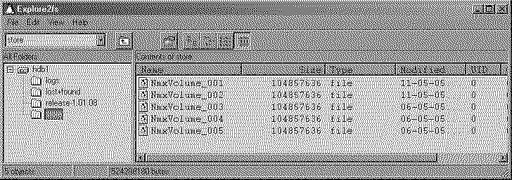

7. Select the first file and then use File > Save As to save it to your hard drive. I created a folder C:\nmx\data\ for this example.

Note that we do not recommend dragging and dropping files from the Explore2fs window. This appears to use very large amounts of computer memory and is slower than File > Save As.

8. Repeat with the remaining files.

9. I will eMail TaurusExtract software to you. This is pre-release development software which will allow you to convert Taurus Store files into Miniseed on a PC. Here are basic instructions:

10. Create a folder on your computer C:\nmx\TaurusExtract\

11. Copy the files from my next eMail into this folder.

12. Ensure your computer has a recent version of Java. We tested this code with JRE1.4.2.

13. Open a command prompt and move to the directory C:\nmx\TaurusExtract\.

14. Read the file ReadMe.txt. This file identifies the arguments of the taurusExtract.bat file, and you will use this batch file to launch TaurusExtract.

15. At the command prompt, type the command "taurusExtract.bat " followed by the appropriate arguments.

16. The program will start. You will not see a GUI.

17. Open your web browser and http://localhost (or http://127.0.0.1). This should open a GUI similar to the Taurus web page.

18. Proceed with normal Taurus commands for creating miniseed files.

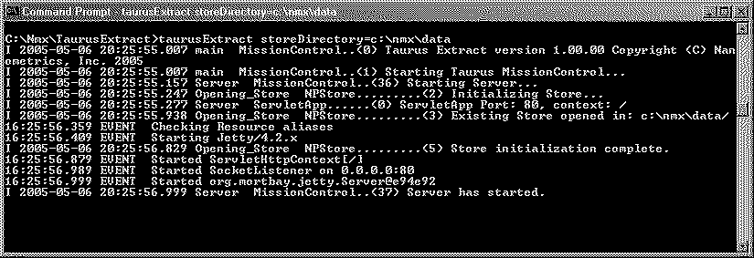

Note that all of the NmxVolume files (which together make the Taurus Store) must be visible to the TaurusExtract program. You cannot copy just 1 or 2 of the files.

Good luck and let us know how well it works for you,

