Supplementary material

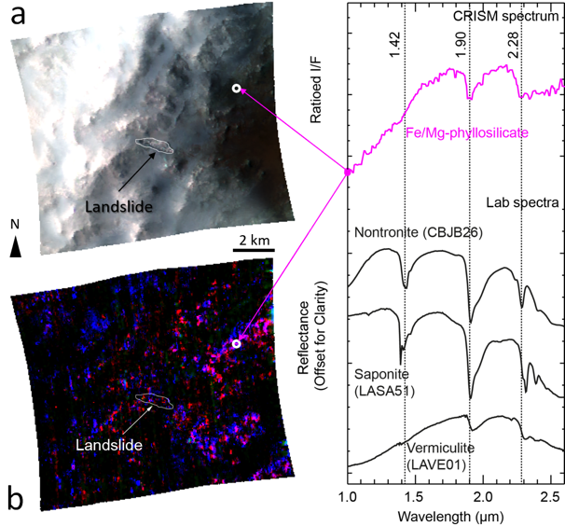
S1-Spectral analysis

Figure S1 - Fe/Mg clays exposed along the impact crater rim in Nili Fossae region. (a) CRISM enhanced IR colour, R= 2.5 μm; G= 1.5 μm; B= 1.1 μm. (b) Spectral parameter map, R= 2.3 μm band depth (D2300); G= 2.2 μm band depth (BD2200); B= 1.9 μm band depth (BD1900R), pink colour: Fe/Mg phyllosilicates, blue colour: hydrated phase. (c) CRISM spectrum of Fe/Mg-phyllosilicate ‘average’ of several pixels divided by pixels of a neutral region compared to laboratory spectra (RELAB library spectra). (CRISM: HRS00024571_07_IF175S_TRR3)

The hyperspectral CRISM observation presented in Figure S1 was processed using the CAT (CRISM Analysis Toolkit; (Morgan et al., 2014)) extension for the ENVI software (Exelis VIS), which was developed by the CRISM Science Team. The spectral parameter maps were computed using the spectral parameter summary products produced by Viviano‐Beck et al. (2014).
Fe-Mg-phyllosilicates (pink tones in Fig.S1b) such as nontronite, saponite, and vermiculite are observed on the bedrock along the impact crater rim and on its floor in the region where the Nilosyrtis Mensae landslide occurs. Other hydrated phase(s) are also associated with the bedrock. Either this or these hydrated phases are not phyllosilicates, or if they correspond to phyllosilicates, then the amount is too small for their diagnostic absorption band at 2.3 µm to be detected.

S2-Topographic profiles
On figure S2, for the three profiles placed for each levee, each cross-section line was placed by connecting with a straight line the points where a given contour line crosses the levee boundary on each side. We isolated each levee by identifying the point at which it rose from the surrounding terrain aided by the image data and extracted the elevation values at these points. We identified and extracted the elevation of the crest of the levee. For each side we calculated the slopes by taking the arctangent of the difference between the base and crest elevations divided by the distance to the crest along the profile. We extracted the maximum height for each levee by taking the maximum difference between the base and crest elevations.

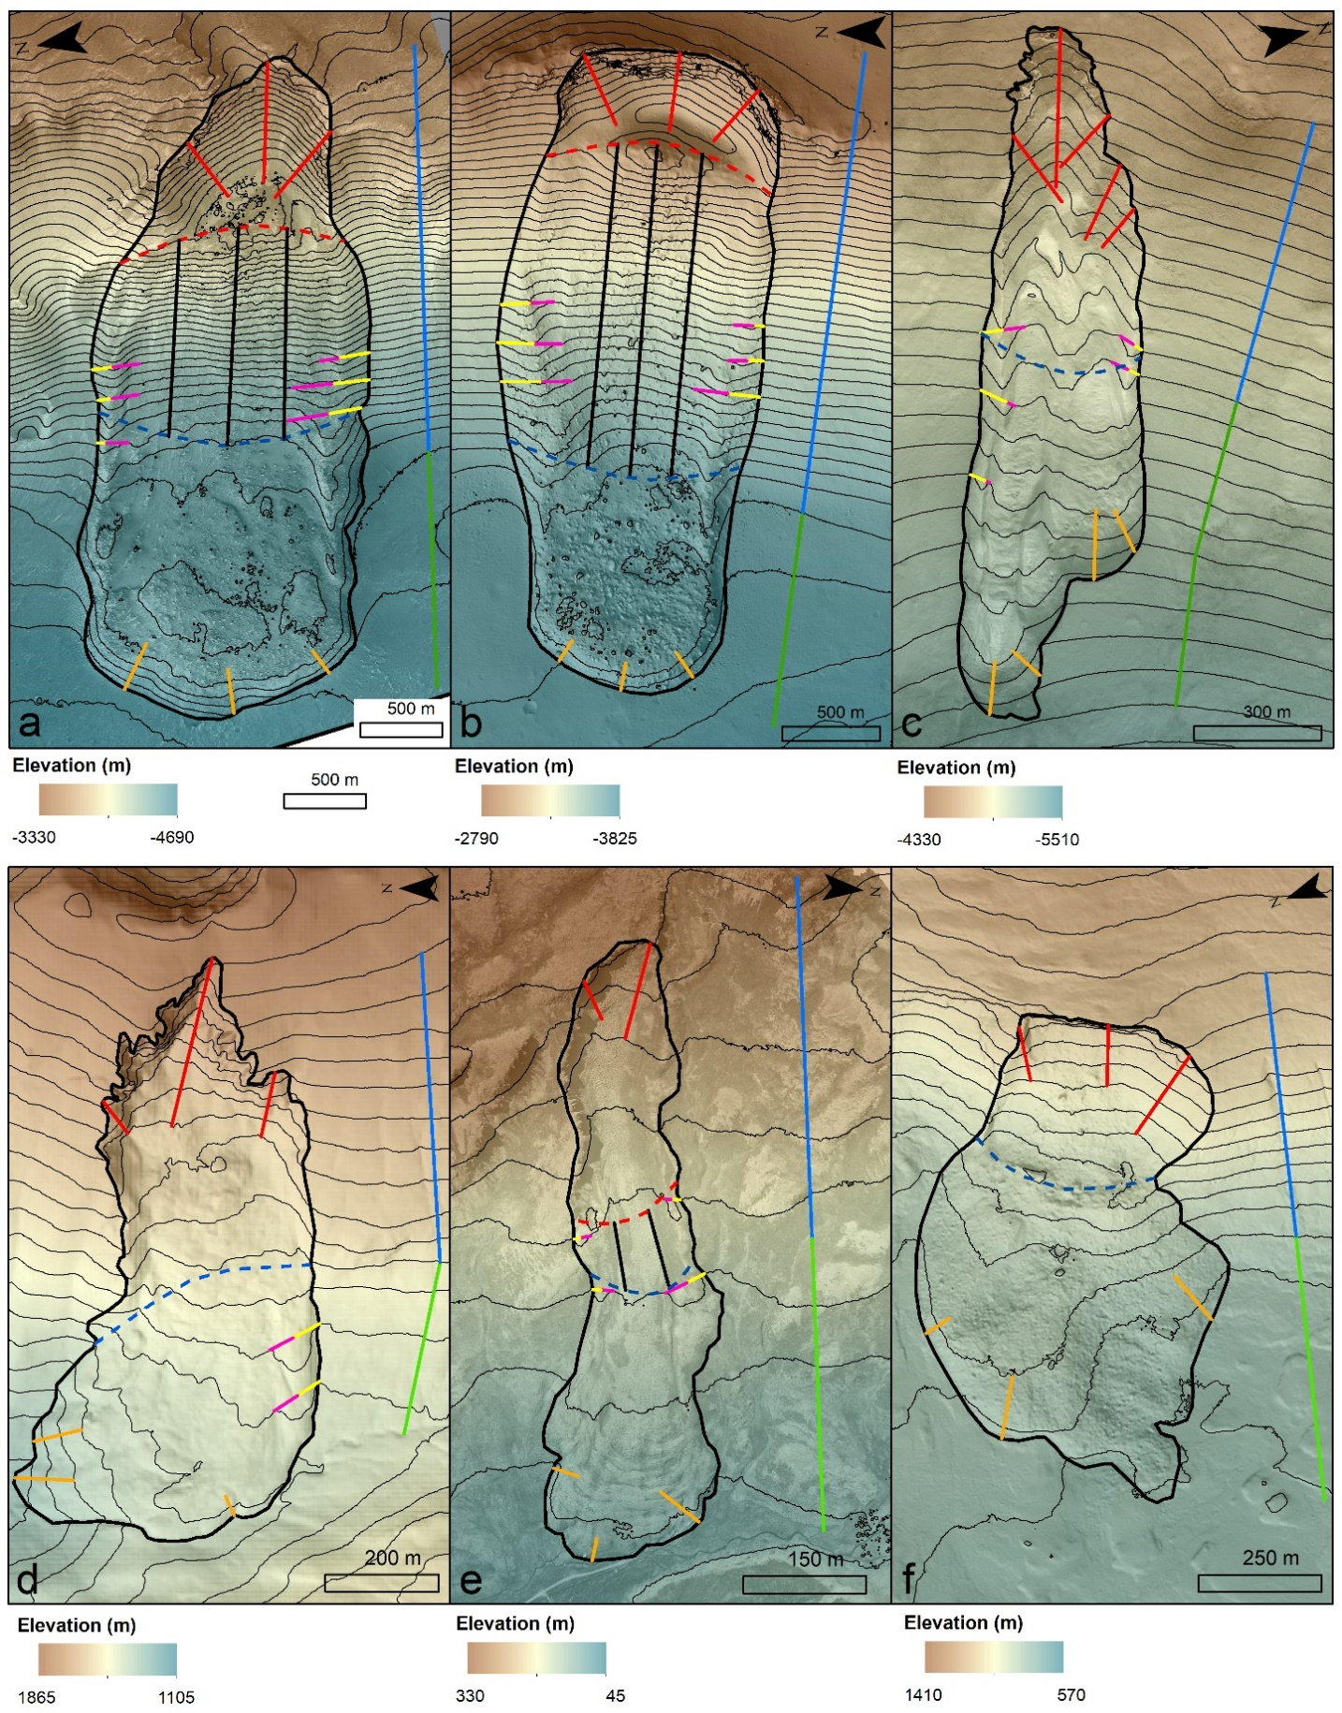
Figure S2 – Position of topographic profiles used to extract measured parameters on Mars (a) Capri Chasma; (b) Chryse Chaos and (c) Nilosyrtis Mensae and on Earth (d) Mount Rainier; (e) Hólmavík and (f) Abisko. Profiles in red, black and orange are used for the erosion zone, the transport zone and front scarp slope calculations, respectively. Profiles outside the landslide’s boundary in blue and in green are used to estimate the slope angle before the landslide occurred and to estimate the slope underlying the deposit zone, respectively. Profiles in yellow and pink are used for outer and inner levee angle calculation, respectively. The dashed line in red delimits the erosion zone and the dashed line in blue delimits the deposition zone. Background images: HiRISE images for (a) ESP_035831_1760, (b) PSP_005701_1920 and (c) ESP_026781_2075; (d) Washington Lidar Portal hillshaded rendering, (e) Aerial image from the Land Survey of Iceland and (f) hillshaded LiDAR data from Geographical Sweden Data.

S3-Grain size sensitivity tests
In order to investigate the influence of grain size in the model using the Pouliquen and Forterre’s law, we performed a sensitivity test on the Capri Chasma landslide by taking grain sizes of L= 1 cm, 1 m, 5 m, 10 m and 20 m (Figure S3). The grain size influences the friction coefficients required to correctly fit the runout distance. The smaller the grain size, the smaller the friction angles must be. In addition, the smaller the grain size, the less rounded the landslide deposit front is. The decision to use L= 5 m for CCh and ChrC and L= 1 cm for Nilosyrtis Mensae is based on morphological observations of the deposition surface. On the CCh and ChrC slides, the entire deposition surface is covered with blocks larger than 5 m. This size has therefore been taken as a reference for modelling. For NM landslide, there are only a few scattered blocks of maximum 10 m in size near the toe of the deposit. Also, we have not identified any blocs of one metre or more on the main deposit it’s that why we choose to take our smaller tested value of 1 cm to conduct the NM simulations.

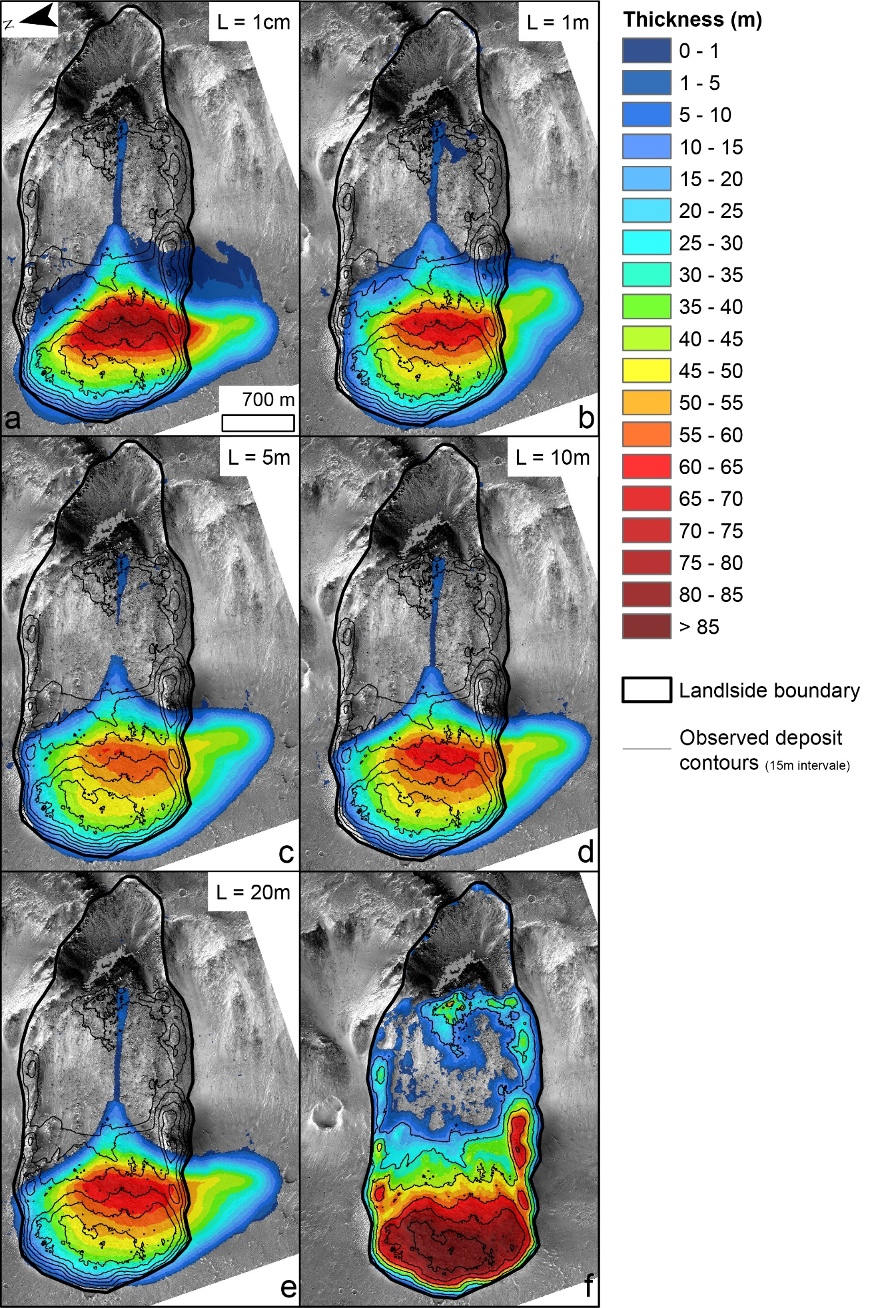
Figure S3 – Final deposit thickness maps resulting from the grain size sensitivity tests applied to Capri Chasma landslide simulation with grain size (L) of (a) 1 cm; (b) 1 m; (c) 5 m; (d) 10 m; (e) 20 m. (f) is the observed deposit on Mars.

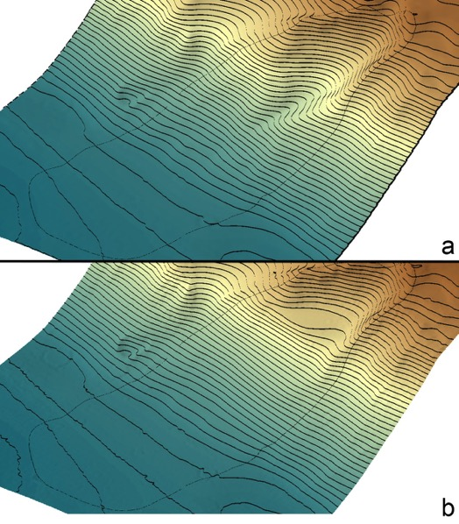
S4-Topographic reconstructions

Figure S4 - 3D view of two alternate topographic reconstructions for Capri Chasma landslide, where the colourised DEM is overlain by semi-transparent hillshaded relief and 25 m interval contour lines in black. (a) Reconstruction with overdeepened areas in the erosion zone. (b) Reconstruction with a flattened base in the erosion zone.
We tested two alternate reconstructions of the initial topography of Capri Chasma landslide to assess the sensitivity of the numerical modelling to this parameter. The actual topography of the erosion zone is unknown as it is partially covered with deposits. We tested the two end members shown in Figure S4.
The reconstruction in Figure S4a includes an over-deepening at the centre of the erosion zone and in Figure S4b a flatter topographic base of the erosion zone. The results of test simulations using these two reconstructions are shown in Figures S5e for the flattened reconstruction and S5f for the overdeepened reconstruction. For the flatter topography (Fig. S5e) some of the mass is retained in the erosion zone as is observed for the real deposit, but significant mass is deflected to one side, hence we did not choose this reconstruction, as it was a poor fit for the observed deposits. For the overdeepened reconstruction (Fig. S5f), we observe almost no deposition at the base of the erosion zone and the deposit is located more centrally within the deposition zone compared to the flattened erosion zone reconstruction. The results are almost indistinguishable from those with no overdeepened portion (Figure 11f), hence for simplicity we decided not to use this reconstruction as the presence/absence of this overdeepened section was impossible to determine.

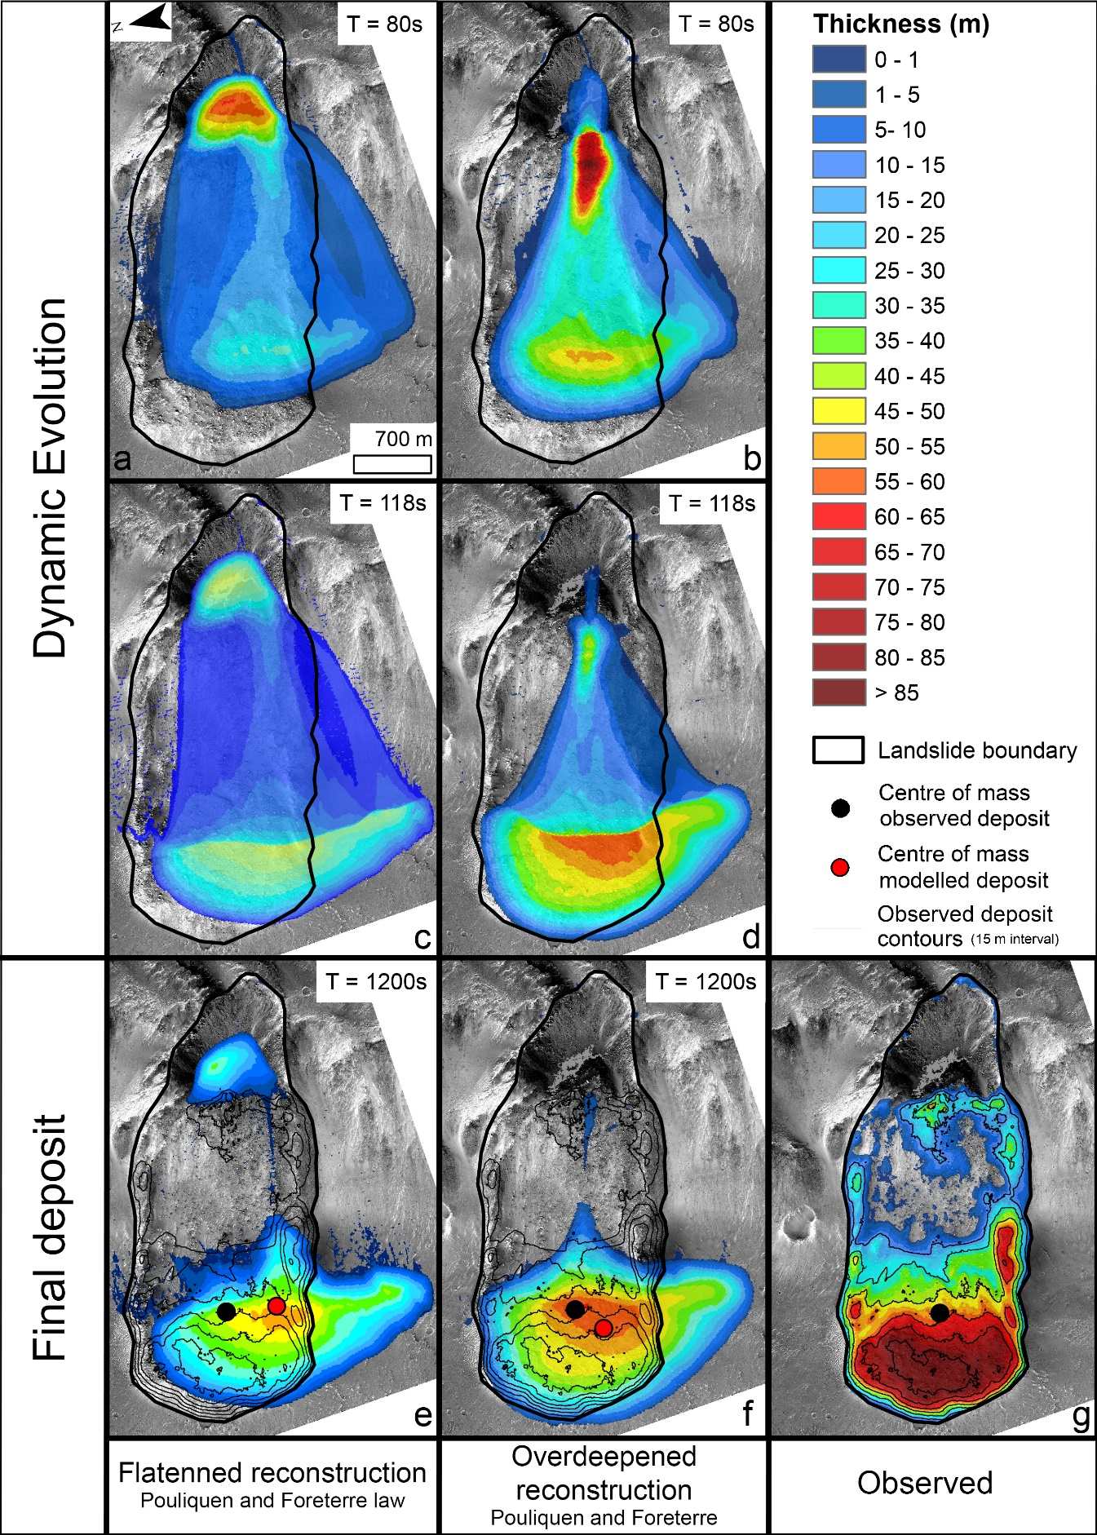
Figure S5 - Dynamic evolution of the simulation using flattened topographic reconstruction of the erosion zone (figure S4b), (a) at T=80s, (c) at T=118s and (e) at T=1200s when the flow is stabilised and using the overdeepened reconstruction (b) at T=80s, (d) at T=118s and (f) at T=1200s when the flow is stabilised compared to (g), the actual deposits. Pouliquen and Forterre's law used with angles of δ₁= 8, δ₂= 18 and δ₃= 11°.

References
Morgan, F., Seelos, F.P., Murchie, S.L., CRISM Team, 2014. CRISM Analysis Toolkit (CAT). The Johns Hopkins University.
Viviano‐Beck, C.E., Seelos, F.P., Murchie, S.L., Kahn, E.G., Seelos, K.D., Taylor, H.W., Taylor, K., Ehlmann, B.L., Wiseman, S.M., Mustard, J.F., Morgan, M.F., 2014. Revised CRISM spectral parameters and summary products based on the currently detected mineral diversity on Mars. Journal of Geophysical Research: Planets 119, 1403–1431. https://doi.org/10.1002/2014JE004627

